**Team Members:**

|  |  |  |
| --- | --- | --- |
| **Member Name** | | **ID** |
| Zainab Hassan Albadi | 2220002372 | |
| Zinab Mukhtar Alrashed | 2220003194 | |
| Zahra Hussain Alshuwki | 2220006062 | |
| Budur Khalaf Alqattan | 2230040030 | |
| Raghad Khalid Bahawi | 2210002700 | |
| Asma Mansour Aldossari | 2220007092 | |
| Aldanah Hassan Almubarak | 2220005044 | |
| Jory Mohammed Alqahtani | 2220006607 | |

**Table of Contents**

**Description:** 3

**Project Implications:** 6

**Web Application Interface:** 9

• **Index page:** 9

• **Product page:** 10

• **Cart page:** 11

• **Login page:** 12

• **Manage product page:** 13

• **Modify product page:** 14

• **Add product page:** 15

• **Contact us page:** 16

• **Help page:** 17

• **About us page:** 18

**Testing Cases:** 19

• **Index page:** 19

• **Product page:** 21

• **Cart page:** 23

• **Login page:** 26

• **Manage product page:** 27

• **Modify product page:** 29

• **Add product page:** 31

• **Contact us page:** 33

**Fulfilled Requirements:** 34

**Database Design:** 35

**Database Tables :** 36

• **Product Table:** 36

• **Admin Table**: 36

**ER Design :** 36

# **Description:**

Glamour is a premium online store dedicated to organic makeup, offering a carefully selected range of high-quality, chemical-free beauty products. Our platform provides consumers with a sustainable alternative to conventional cosmetics, ensuring both safety and effectiveness.

We specialize in organic foundations, lipsticks, eyeshadows, and skincare-infused makeup, all formulated with natural ingredients to promote healthy skin. At Glamour, we are committed to clean beauty, sustainability, and ethical sourcing, making it easier for customers to embrace a healthier approach to makeup.

With a seamless shopping experience, secure payment options, and expert beauty insights, Glamour is the go-to destination for those seeking high-performance, eco-friendly cosmetics.

**Task Distribution:**

|  |  |
| --- | --- |
| **Names** | **Task Description** |
| Zainab Hassan Albadi | Project Leader  HTML: 1. Index page 2. Manage Products page  3. About Us page  Header  Footer  PHP: Fetching products from DB ( 1. Index page  2. Product Details page )  Help Popup (Product Details page)  CSS: 1. Add Product page 2. Login page  3. Modify Product page  JavaScript: Search functionality  Test Login page |
| Zainab Mukhtar Alrashed | Contact us page  Database  Testing index page  Welcome massage  Test authentication |
| Zahra Hussain Alshuwki | Testing the add product page  Delete product from the DataBase  Show error message in case login fails  HTML Cart page |
| Budur Khalaf Alqattan | Testing the contact page  Add new product to DB  retrieve product information   from DB: manager page  HTML manage product and login |
| Raghad Khalid Bahawi | Test update page  Update quantity after purchase in DB  Fulfilled Requirements  HTML product details  Contact us form submit (php) |
| Asma Mansour Aldossari | ER Diagram  Testing the product page  Project Implications  Accessibility Requirement |
| Aldanah Hassan Almubarak | Testing manage product page  Past Purchases  Modify product in DB  HTML Help page |
| Jory Mohammed Alqahtani | Testing cart page  Check product quantity from DB  Check fulfilled requirements  HTML Manage product page , add , modify and delete |

# **Project Implications:**

**1. What are the issues faced by that organization which are going to be solved through your website?**

Glamour encounters multiple obstacles that the website seeks to tackle:

**1.1- Consumer Awareness:** A significant number of consumers/buyers are not knowledgeable of the advantages of organic cosmetics and the detrimental impacts of synthetic components and environmental ignorance.

**1.2- Market Rivalry:** The cosmetics sector is flooded with traditional offerings, making it challenging for organic brands to differentiate themselves, have their own reputation and effect on the community.

**1.3- Confidence and Clarity:** Shoppers frequently feel uncertain about product labeling and the validity of organic assertions.

**1.4-Accessibility:** Locating premium organic items can be difficult without a specific platform.

**2. What are the technological features that you have included in the website to solve these problems?**

**2.1- Learning Materials:** Extensive and encouraging information regarding the advantages of organic components, environmental sustainability, and product safety to inform consumers of the value put in these products.

**2.2- Easy-to-Use Interface:** A straightforward and to the point design aimed at improving the shopping experience and enables effortless navigation throughout the shopping experience.

**2.3- Safe Payment Choices:** Various secure payment options to enhance and help consumer confidence and guarantee safe and private transactions.

**2.4- Product Evaluations and Scores:** Consumer-created insights to assist prospective customers in making educated decisions.

**2.5- Search and Filter Features:** Enhanced search capabilities that enable users to locate items according to particular requirements (e.g., skin type, issues).

**2.6- Transparency in Sourcing:** Clear information and labeling regarding the sourcing of ingredients and their certifications.

**3. List down additional problems/challenges that may result due to your system.**

**Although the website tackles various issues, it could also create additional ones:**

**3.1- Technical Problems:** Website outages or technical malfunctions may disrupt the shopping experience.

**3.2- Data Security:** Managing sensitive client information presents risks associated with data leaks.

**3.3- Consumer Confusion:** Misreading educational materials might result in misconceptions regarding product effectiveness.

**3.4- Logistical Issues:** Supply chain complications might impact the availability of products and their delivery schedules.

**4. How the tools used in project helped you to design an appropriate system?**

**The instruments used in the project were vital in creating an efficient system:**

**4.1 - Website Development Instruments:** CSS, PHP, JavaScript, HTML all offered a strong foundation for constructing the e-commerce site, guaranteeing scalability and user friendliness.

**4.2- Data Managing Tools:** MySQL, XAMPP assisted in monitoring all data throughout the sites, informing changes and consistencies in the website's content.

**4.3-Content Management Systems (CMS): These tools enabled simple updates and administration of educational materials, ensuring content remains current and pertinent.**

In general, these technologies facilitated the development of a user-focused platform that successfully meets consumer demands while aligning with the organization's objectives.

# **Web Application Interface:**

## **Index page:**



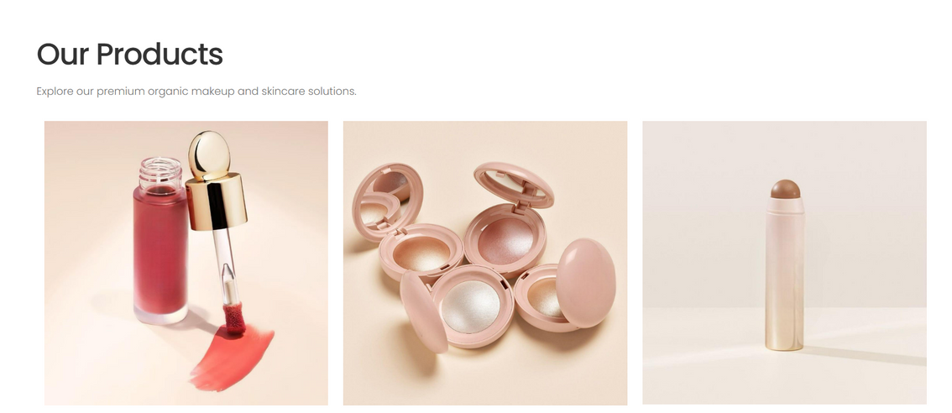

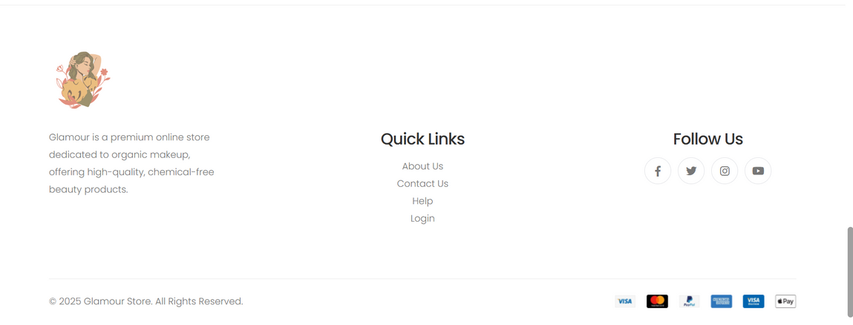

## **Product page:**

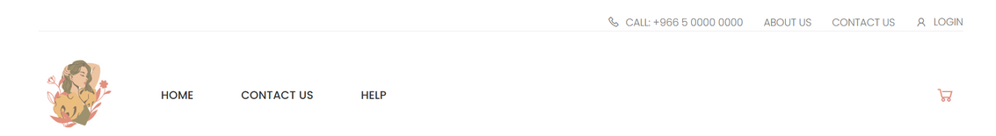

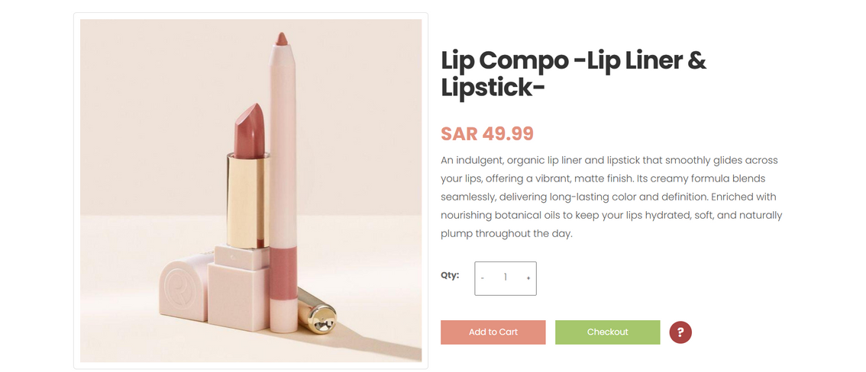

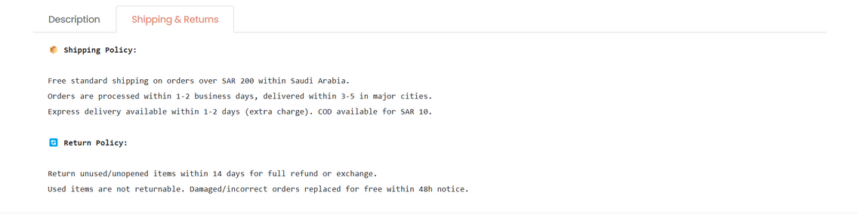



## **Cart page:**



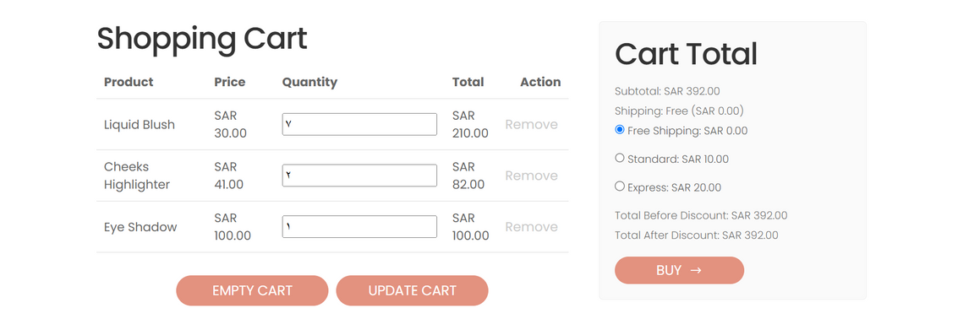



## **Login page:**



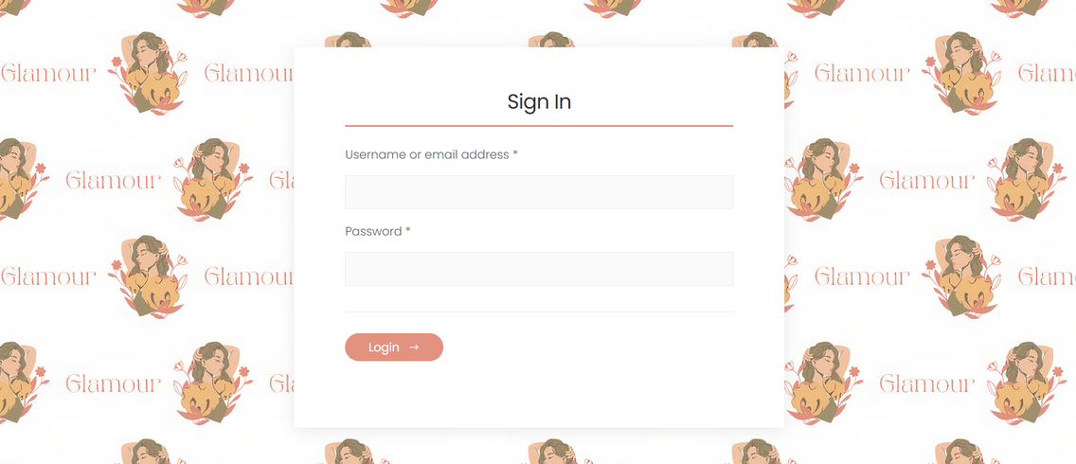



## **Manage product page:**

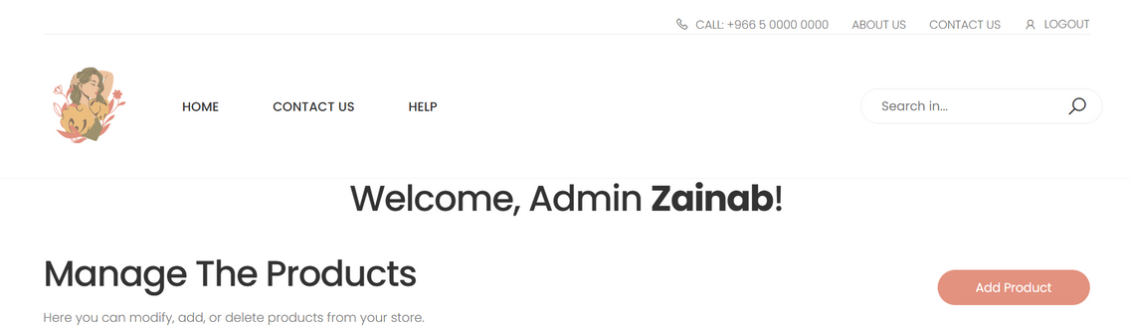

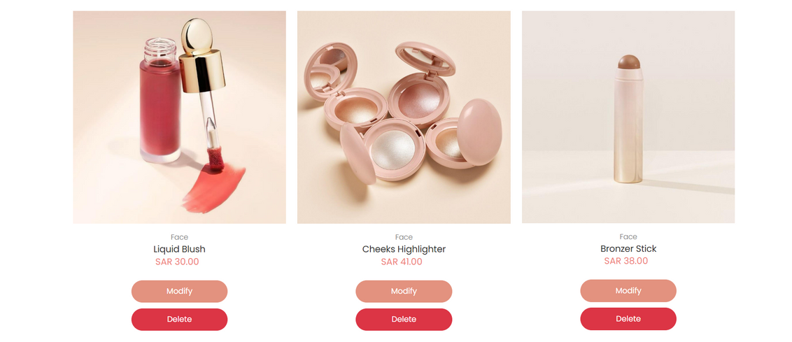



## **Modify product page:**

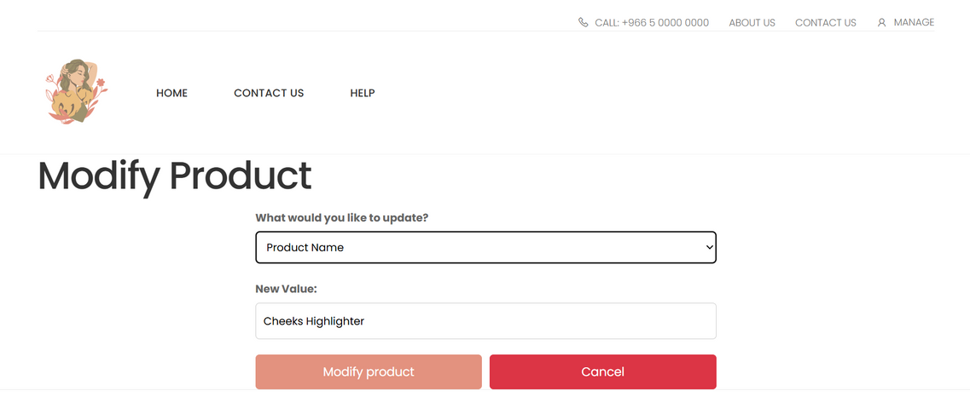



## **Add product page:**

﻿

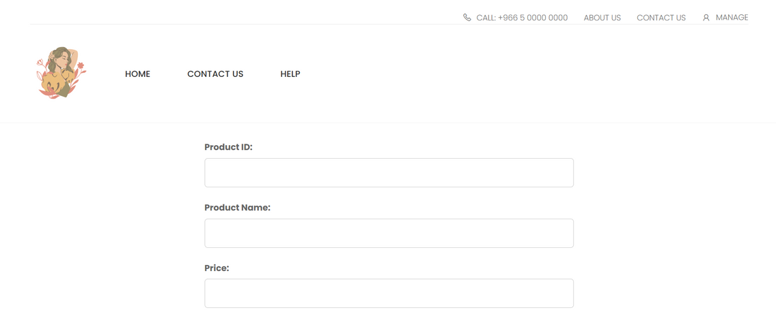

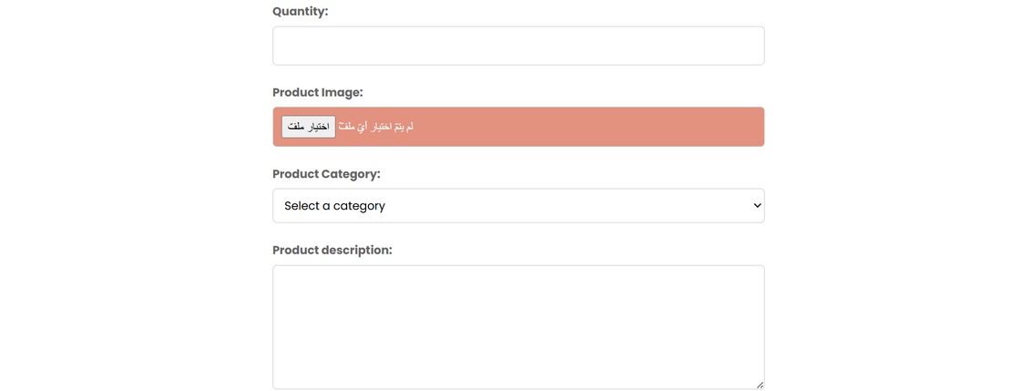





## **Contact us page:**



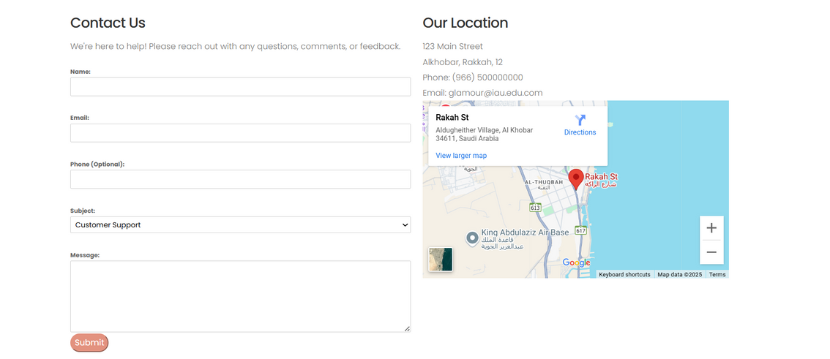

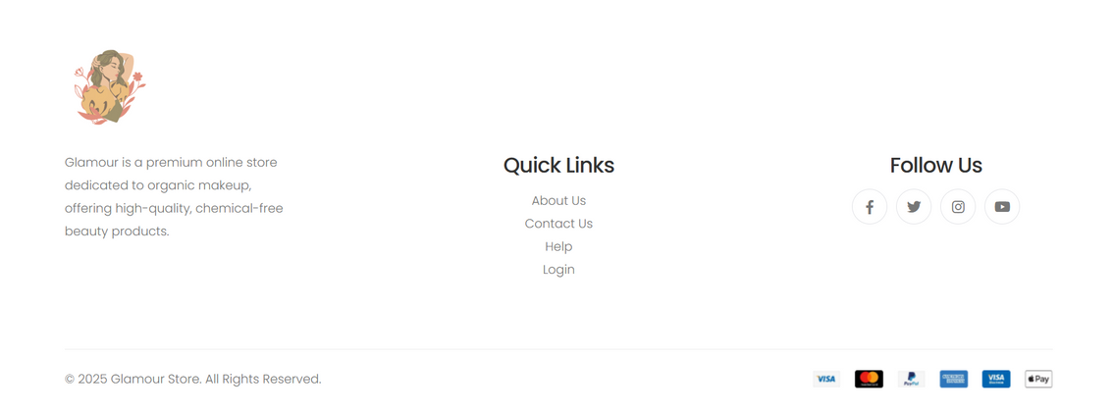

## **Help page:**



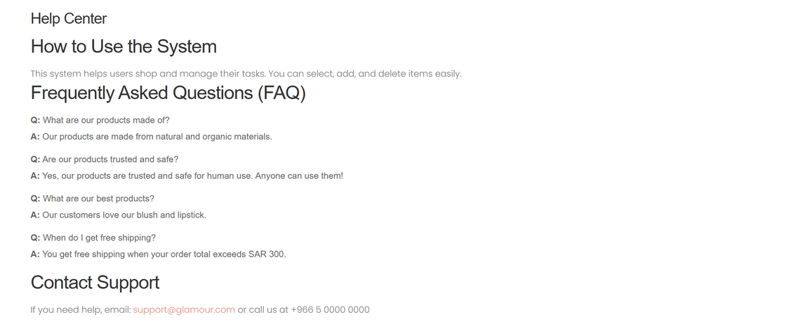

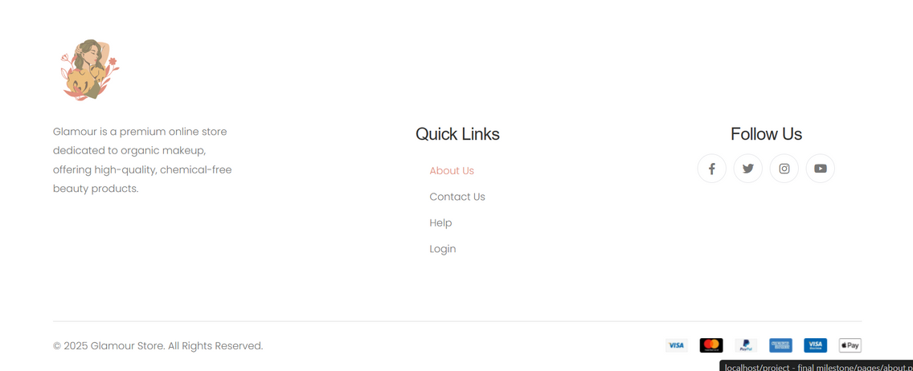

## **About us page:**





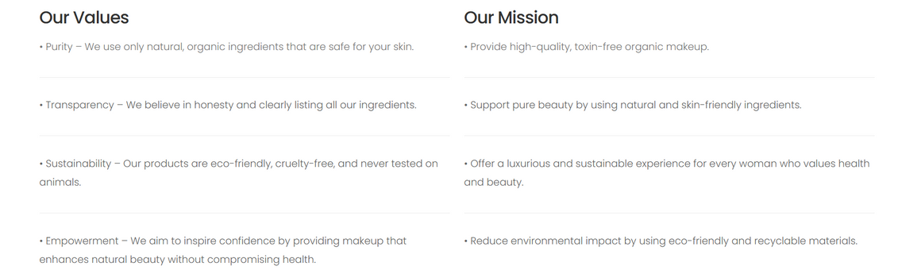

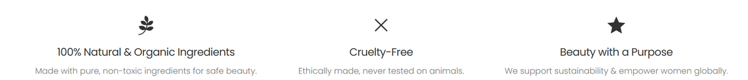



**Testing Cases:**

## **Index page:**

searching for product will retrive the proudct

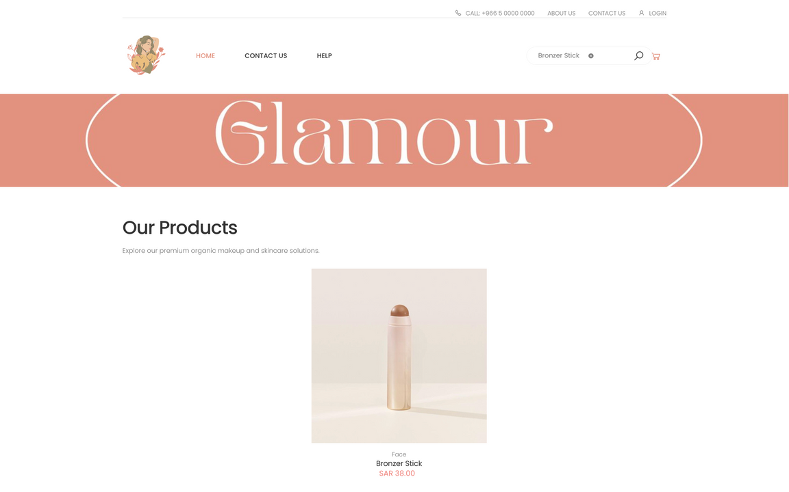

pressing on product will take you to product page which contains product detail

pressing on cart icon will take you to the cart

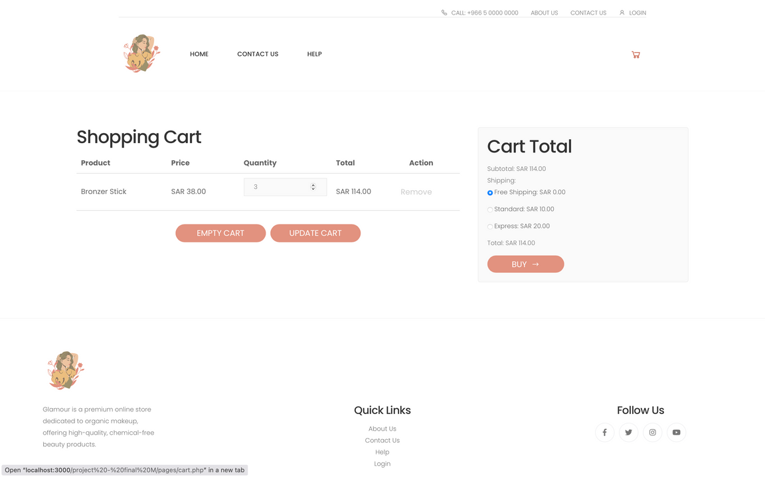

hovering on social media icons will display their names and pressing on them will take you to our social media platform

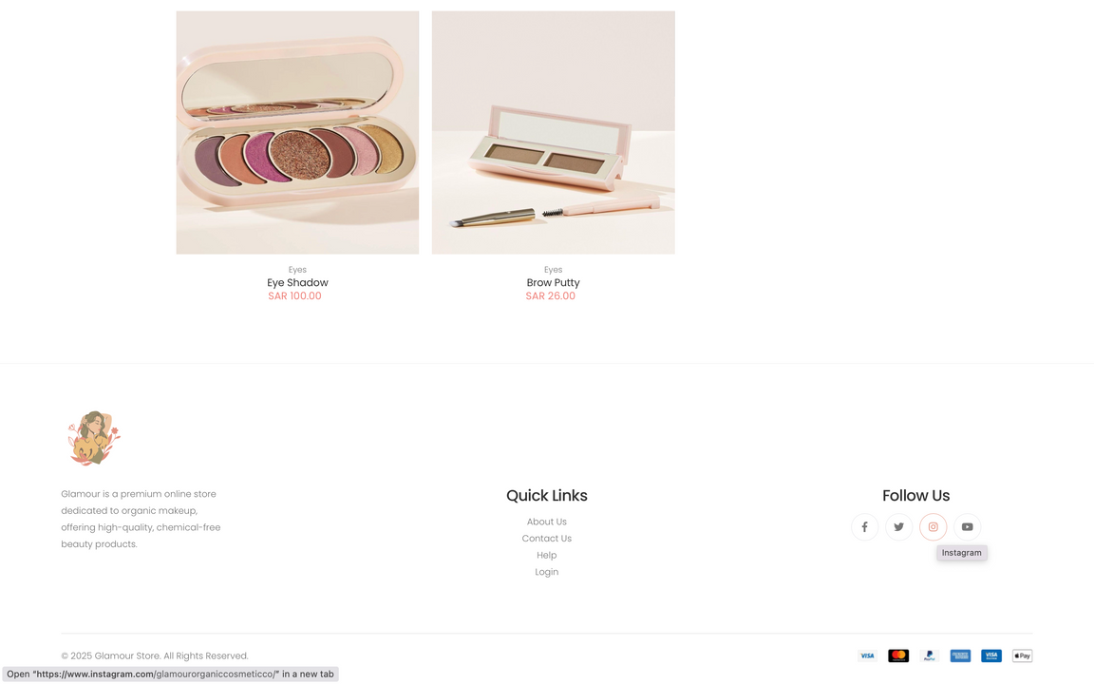

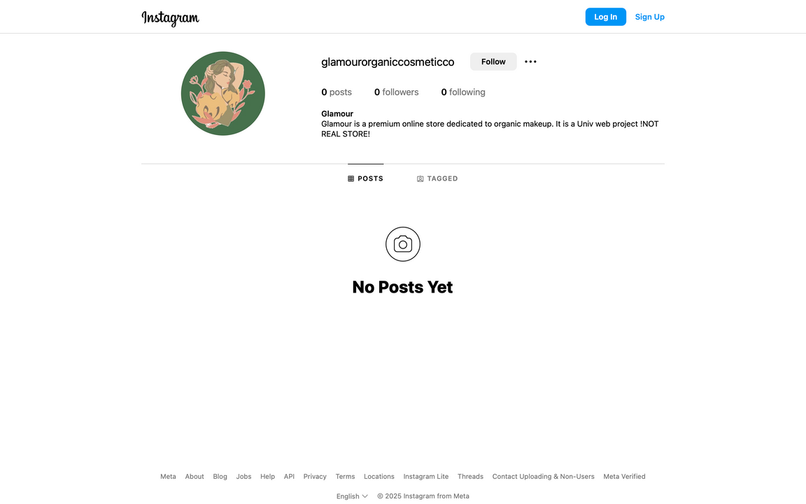

Testing verfied that all the links in the header or in the footer “quick links and follow us” will take you to the intendent page.

## **Product page:**

**product** has been selected by user showing the **description** of the product, **price of the product**, **quantity**(press + to add, - to subtract), **Add to cart**, **Check out** and **help button**.



**product description**, **shipping and return** policies available under the product.



When pressed **Add to Cart** button a pop message validating the product is added to cart and can re-direct the user to view the product in cart by pressing **View Cart** button.

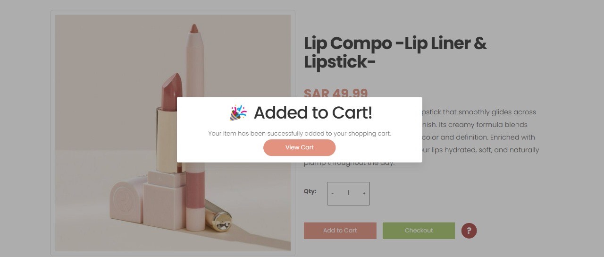

The **red question mark button** when pressed shows a **Need Help?** popup message answering the most common problems with the support email below. User can continue using the website after pressing **Got it! button**.

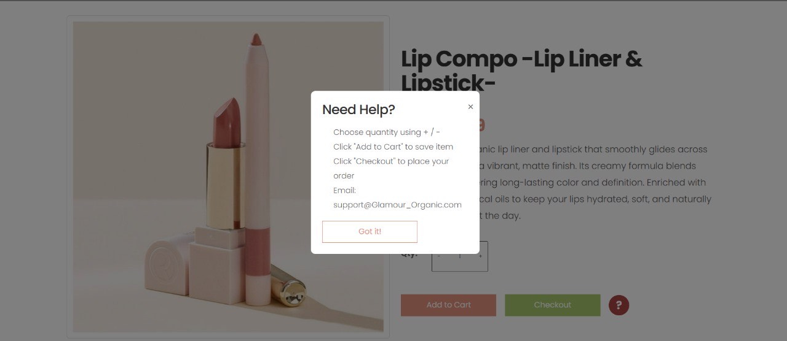

When a Customer wants to add a larger number of a product than what is available in stock a message will appear informing the user of the situation. resulting on only adding the quantity available to the cart.

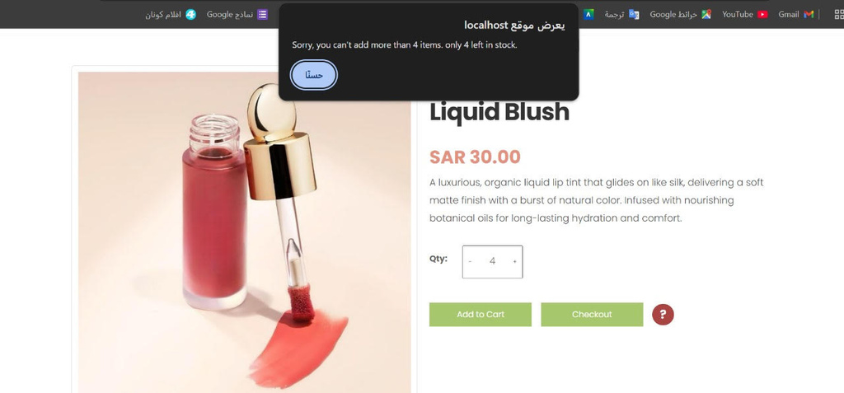

When the product quantity reaches zero, a “Sold Out” message appears in red. The user is unable to add the product to the cart, and the “Add to Cart” button is replaced with a disabled “Sold Out” button.

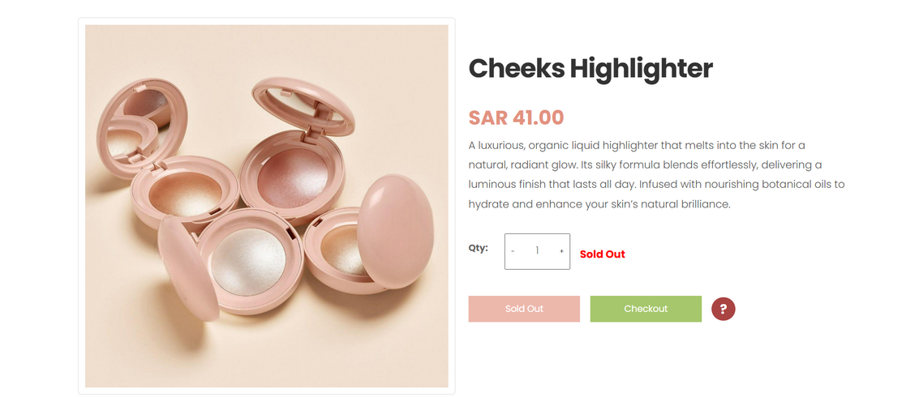

## **Cart page:**

when a customer wants to **add a product that is “ out of stock ”** a massage will occur to show that it’s out of stock currently.

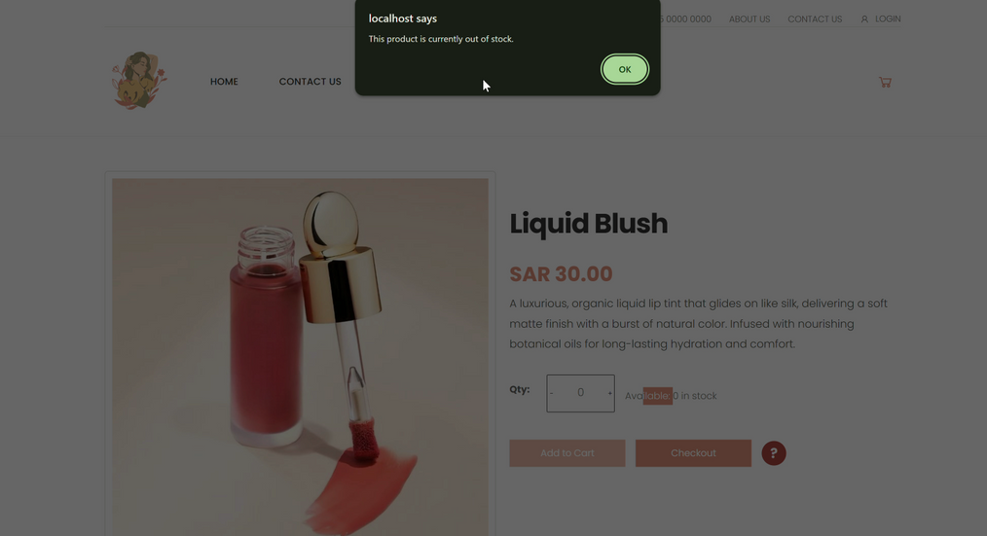

if the customer wants to **change the quantity** for the product and its exceed the quantity in the stock it will not allow to add more than the specified quantity in our DB.

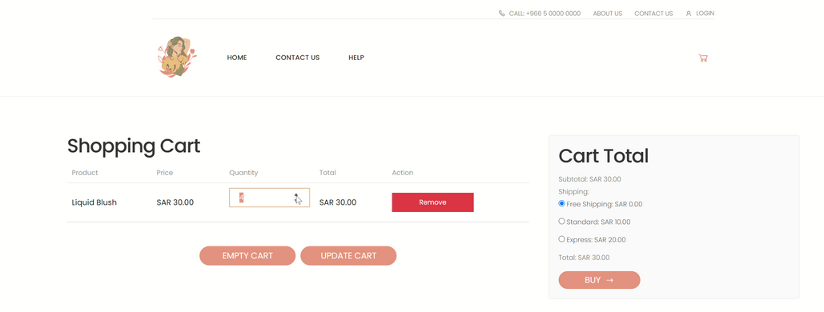

If the customer **click update** cart and typed the num of quantity exceed the num of available stock it will show a red error massage and will give instructions of how many are left in the stock. 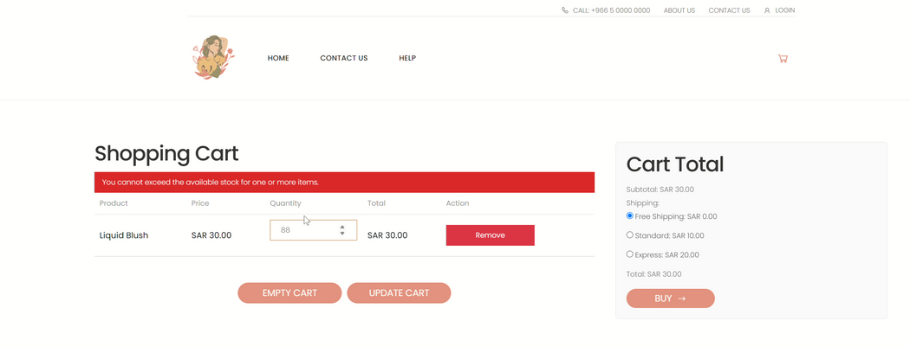

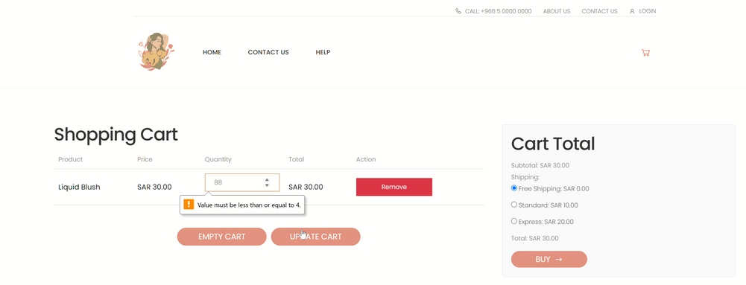

if the customer **change the shipping method** immediately the total cost will be changed.

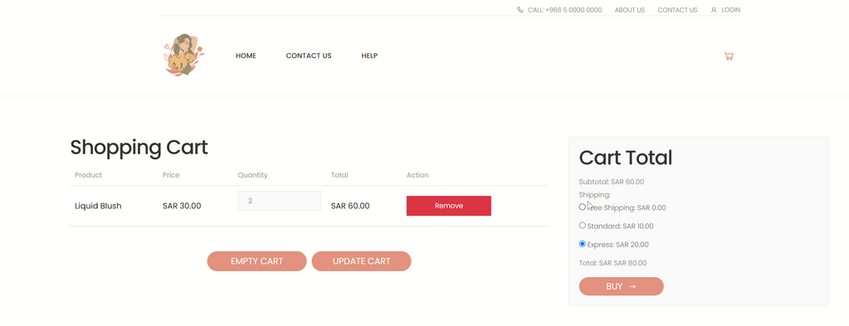

If the customer **click Remove** it will directly remove the chosen product , **clicking EMPTY CART** will remove all the product that was added.

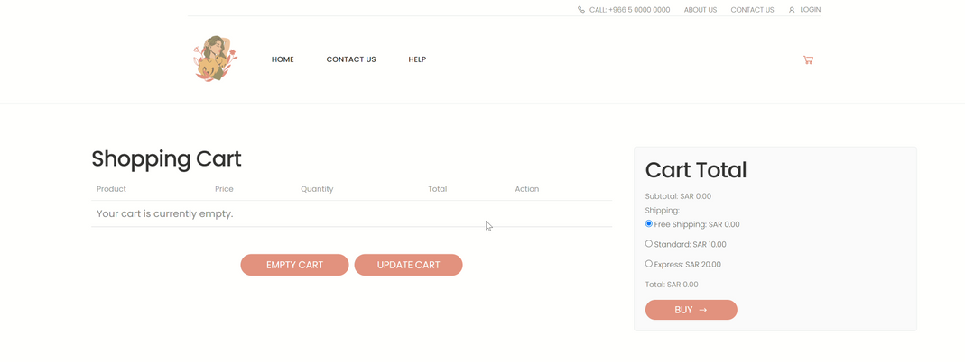

When the user clicks the “Buy” button, a confirmation message appears saying “Thank You! Your order has been placed successfully.” At the same time, the product stock is updated automatically in the database to reflect the new quantity.

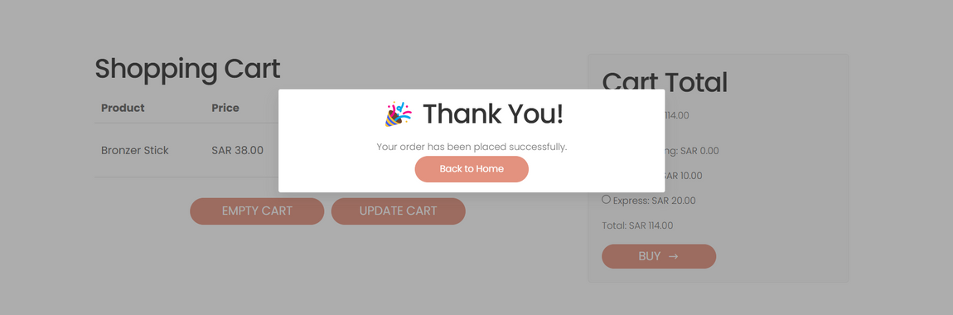

## **Login page:**

When valid credentials (correct email/username and password) are entered and the **Login** button is clicked, the user is redirected to the **Manage Products** page.

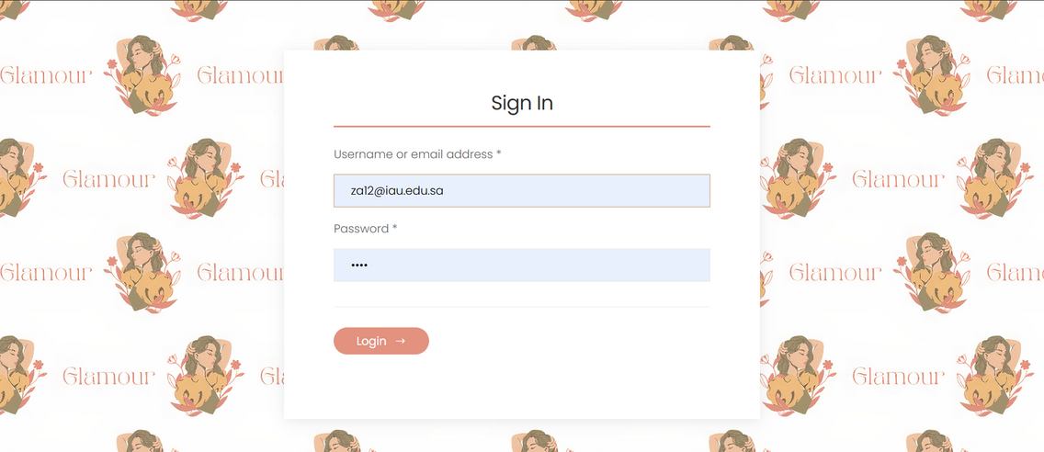

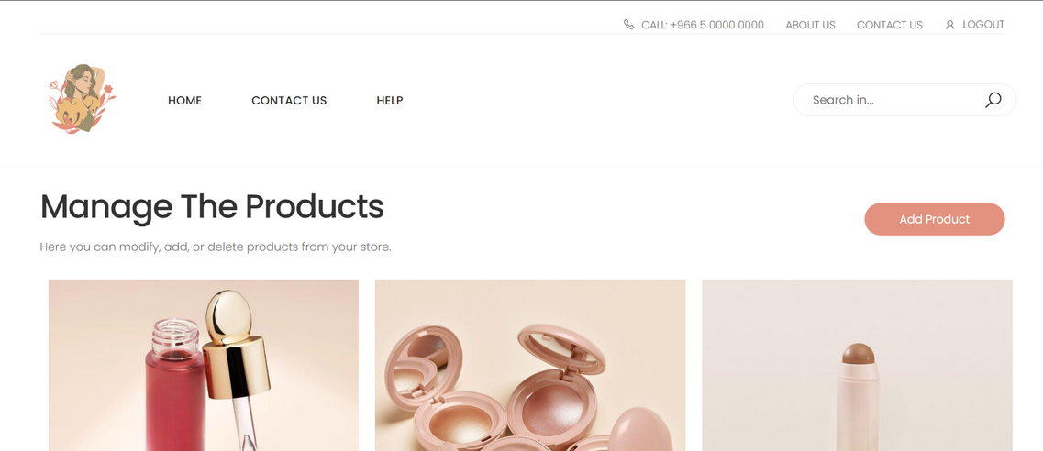

if the credentials are incorrect, the login page reloads and displays an **error message** indicating that the username or password is invalid.

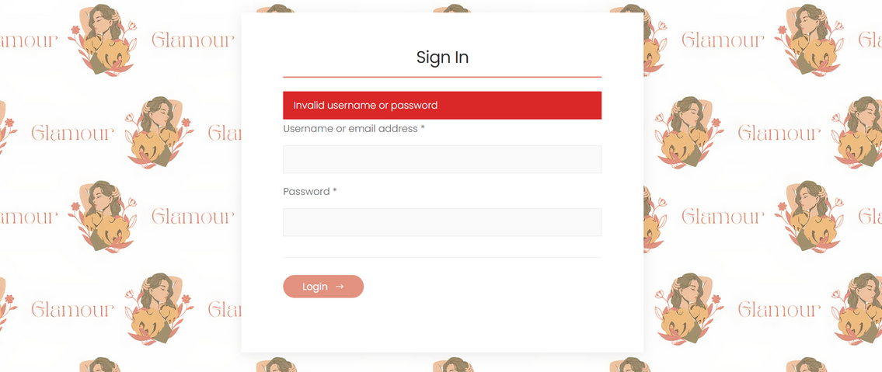

## **Manage product page:**

If the user tries to access the Manage Products page directly by typing the URL without logging in, they are redirected to the login page with a message: **“You must log in first.”**

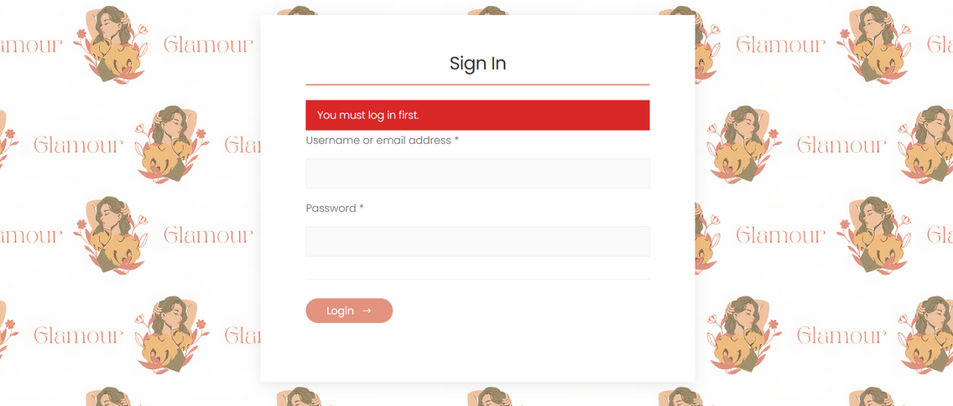

After the manager logs in, they are redirected to the Manage Products page. There, they can add, modify, or delete products as needed.

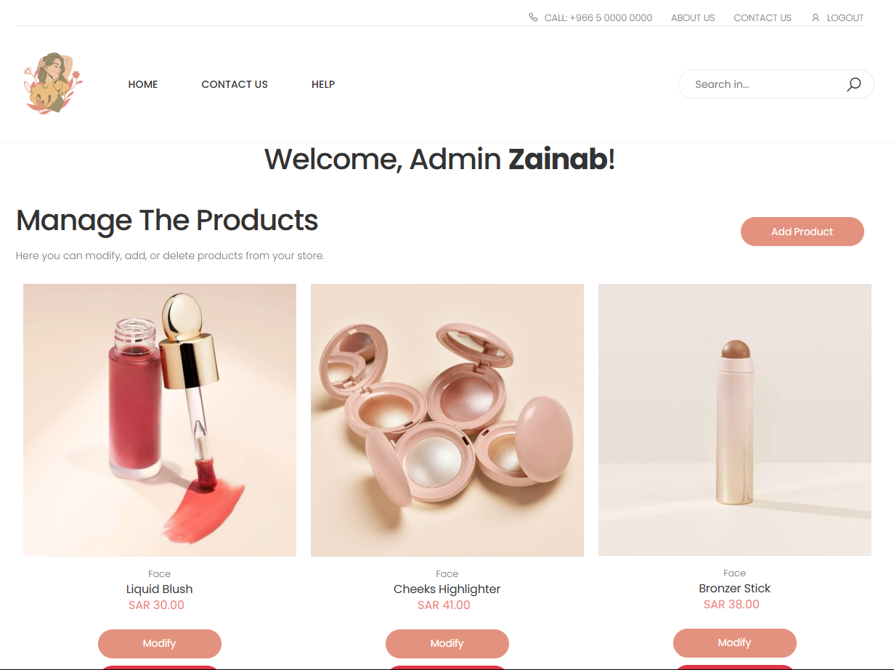

If the manager wants to delete a product, a confirmation message will appear to ensure the action is intentional.

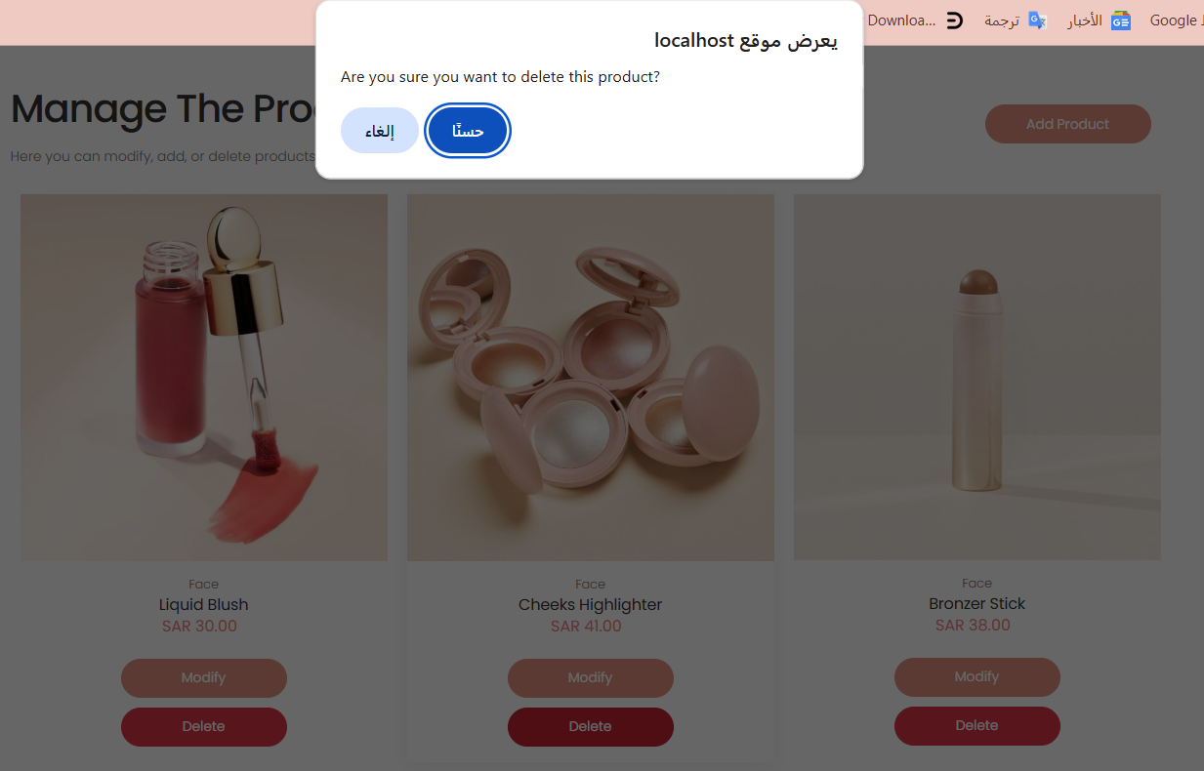

After the product is deleted, the database is updated, removed from the website, and a message says, "Product deleted successfully."

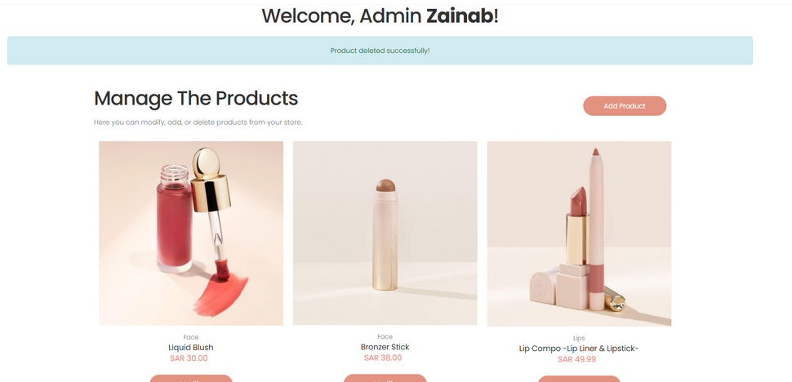

## **Modify product page:**

When the admin **clicks on modify,** it will be green and will make it go to the other page.

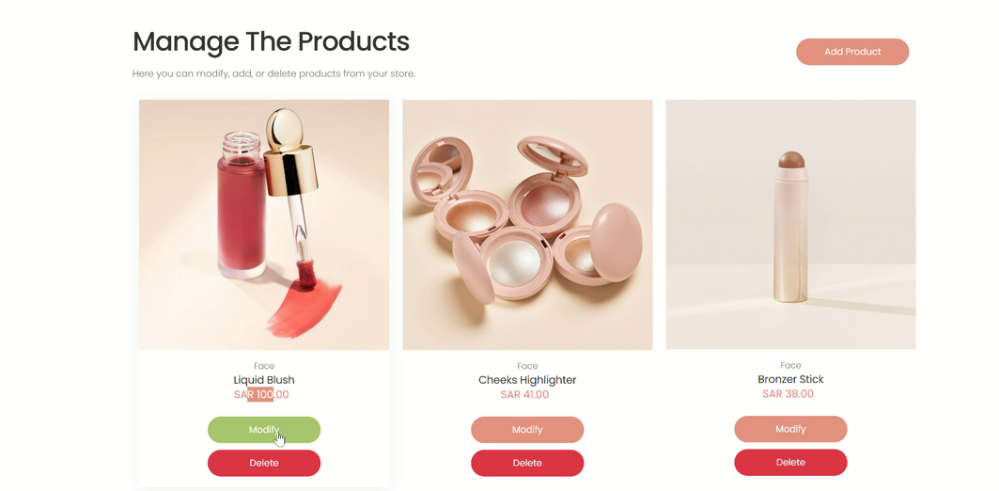

It will show for the admin a list of the attribute that he **want to change.** if the admin **selects the price** field, the price will display.

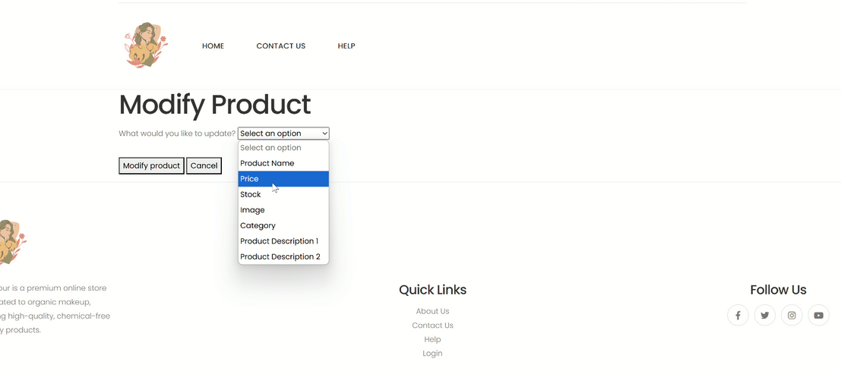

The admin can change the value based on the validating format.

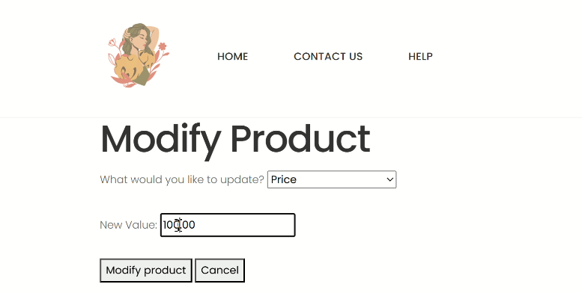

**After successful updating,** it will go back to the manage product page and will show a message “ product updated successfully! ”.

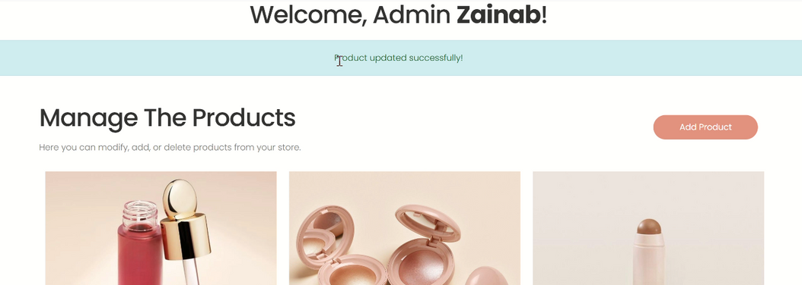

The **updated price** will show right away.

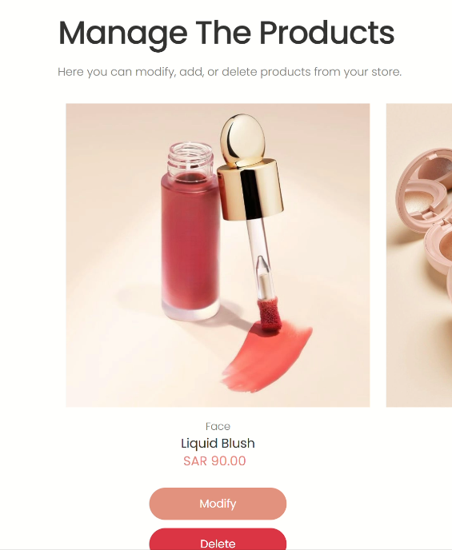

## **Add product page:**

If the manager wants to add products, they click on "Add Products" and are redirected to the Add Product page. There, they enter product details like name, description, quantity, and image, and the product is added when they click the "Add Product" button.

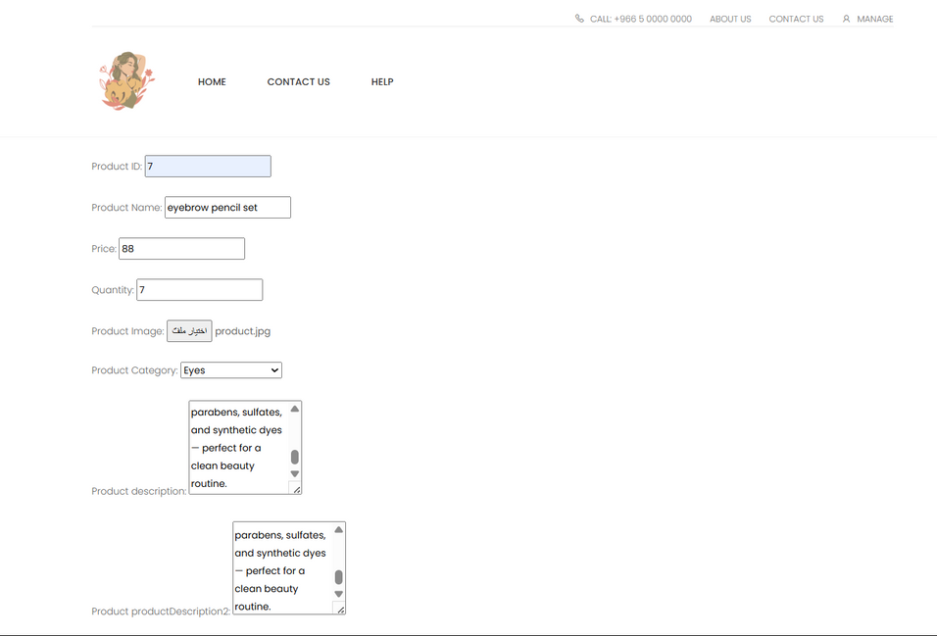



After that, a message appears saying "Product added successfully." The database is updated, and the product is displayed on the website.

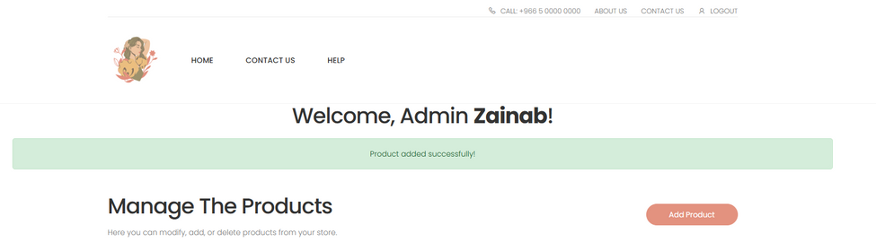

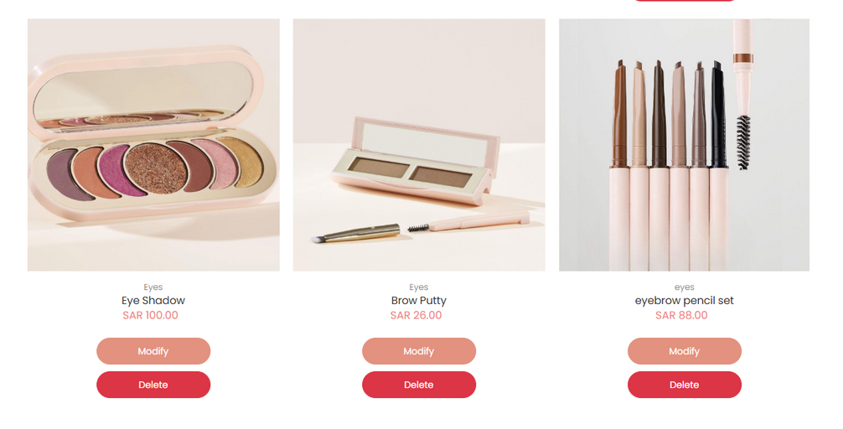

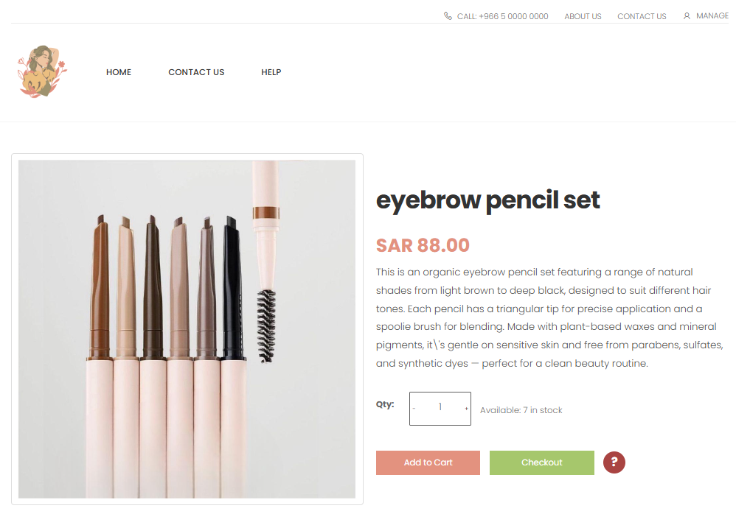

## **Contact us page:**

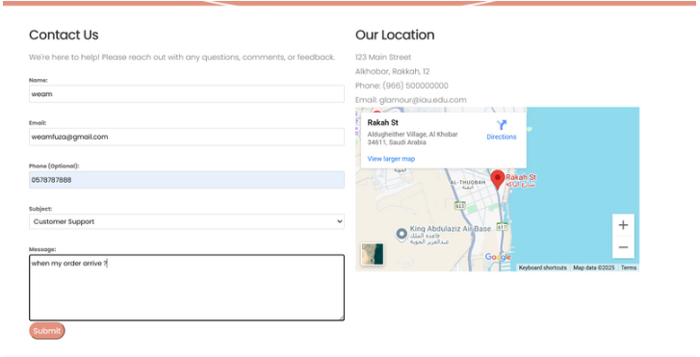

The image shows the main interface of the Contact Us form, where users can enter their details (name, email, phone, subject, and message) to get in touch with the support team. The page is designed to be simple and user-friendly, and it also includes a map showing the organization’s location.

The **PHPMailer** library was used in the backend to handle form submissions and send user messages directly to our official email. This ensures that all inquiries are received quickly and securely via email, enhancing the user experience and providing an effective way to communicate with the team.

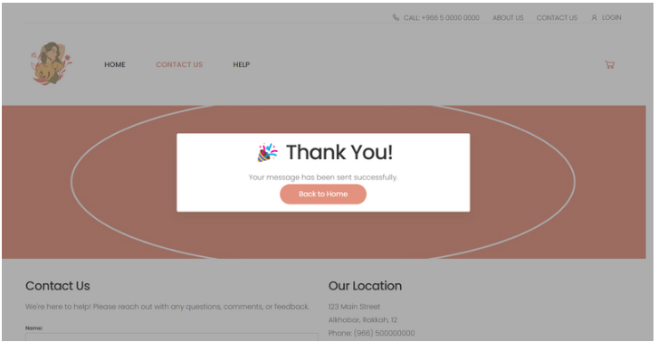This image shows the confirmation message displayed after the user successfully submits the "Contact Us" form. It reassures the user that their message has been sent to the support team.

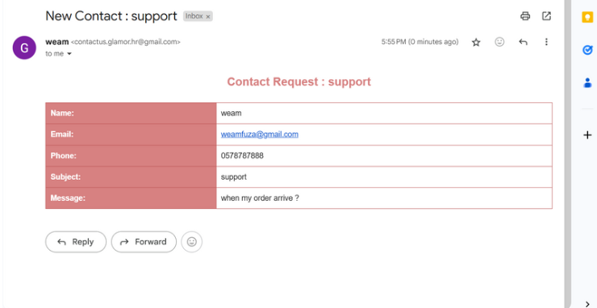This image shows the email that was successfully received after the user submitted the contact form from the "Contact Us" page. The email includes all user-submitted information: name, email, phone number, subject, and message.  
 This message was sent using the **PHPMailer** library, which was integrated with the backend of the form to enable automatic email delivery to the support inbox.  
 This step confirms the final stage of the process, following the "Thank You!"

# **Fulfilled Requirements:**

* Database design (done )
* Web Design (done )
* Display Products (done )
* Display Product Details (done )
* Add to Cart (done )

* Checkout (done )
* Buy (done )

* Authenticate Managers (done )

* Add New Product (done )
* Search for a product to modify or delete (done )
* Display address and location map (done )
* Past purchases (done )
* Forms Validation (done )

* Help window (done )
* Accessibility (done )
* Efficiency (done )

# **Database Design:**

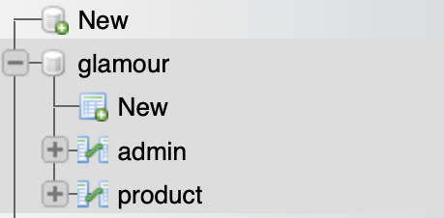

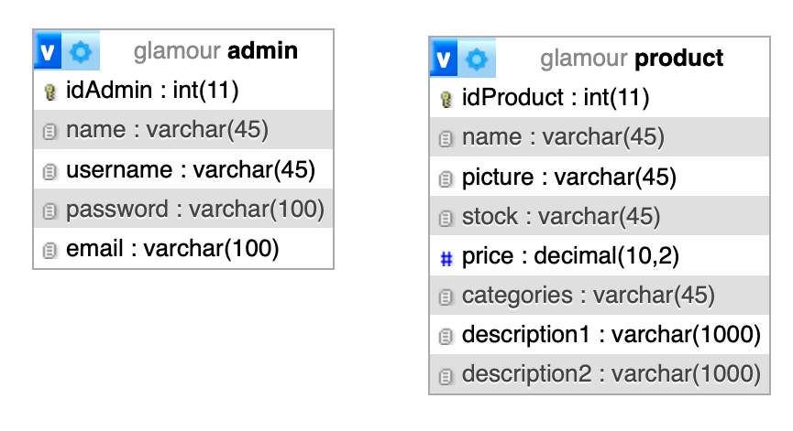

# **Database Tables :**

## **Product Table:**

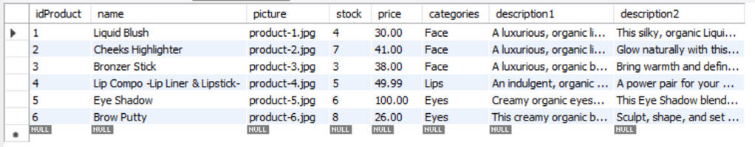

## **Admin Table**:

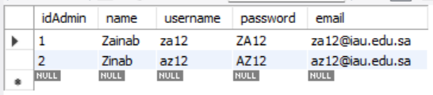

# **ER Design :**

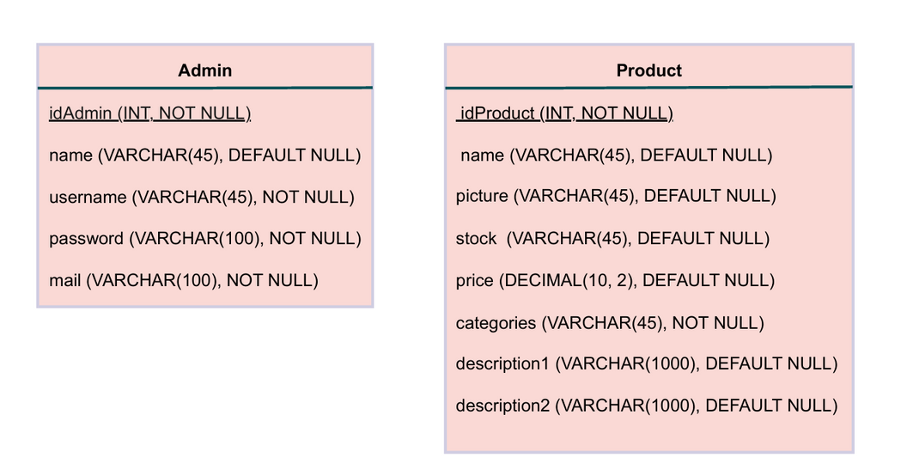

**Leader: Zainab Hassan Albadi.**